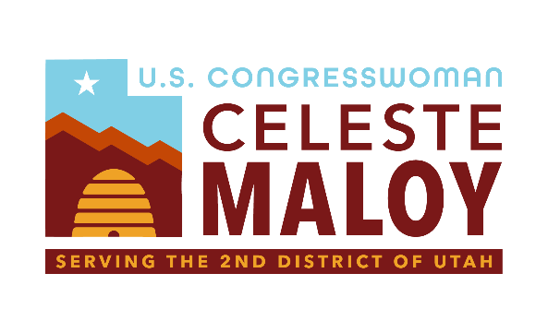
119th Ways and Means Member Day Hearing – Rep. Celeste Maloy

Chairman Smith, Ranking Member Neal, and members of the committee, I’m grateful for the opportunity to testify today on critical tax reform that will significantly impact the hardworking people of Utah. I am here to advocate for policies that will foster economic growth, create jobs, and ensure a prosperous future for all Utahns – and for all Americans. Today I want to zoom in on one very important issue that I know everyone here is already familiar with – the death tax.
I urge the Committee to repeal the death tax, also known as the estate tax. In Utah, where family-owned businesses and farms are the backbone of our economy, the death tax forces the sale of assets to pay for the tax liability, undermining generational wealth and economic stability. Repealing this tax will allow families to pass on their hard-earned assets without the fear of financial ruin.
The death tax is a levy on the transfer of wealth from one generation to the next. It penalizes families who have spent their lives building businesses, farms, and legacies that they hope to pass on to their children and grandchildren. In Utah, the death tax can tear apart the very fabric of our communities. Utah has more than 300,000 small businesses, including about 14,000 family farms.
A study performed by USDA’s Economic Research service indicated that 98% of American farms are family-owned and operated. These families that work tirelessly for decades to build a successful small business – investing their time, energy, and resources into creating jobs, contributing to the local economy, and providing for their loved ones – shouldn’t have to face a hefty tax bill that they may not be able to afford – especially after losing a loved one.

Repealing the death tax is not just about fairness; it’s about taking better care of rural economies in America. Studies have shown that eliminating the death tax would lead to increased investment, higher wages, and more jobs. A recent study by the Heritage foundation estimates that eliminating the death tax would boost the U.S. economy by $46 billion over the course of 10 years and generate an average of 18,000 private-sector jobs annually.
When families are free to pass on their businesses and assets without the fear of a crippling tax burden, they are more likely to invest in their communities and expand their enterprises.
The death tax generates relatively little revenue for the federal government compared to the economic harm it causes. The administrative costs of enforcing the tax are high, and the revenue it brings in is a drop in the bucket compared to the overall federal budget. Repealing the death tax would have a negligible impact on government revenue but a profound positive impact on American families and businesses.
Mr. Chairman, thank you for the opportunity to allow me to come testify in support of repealing the death tax. Doing so will benefit small business owners and family farms in my home state, and throughout the country.
Thank you and I yield back.

