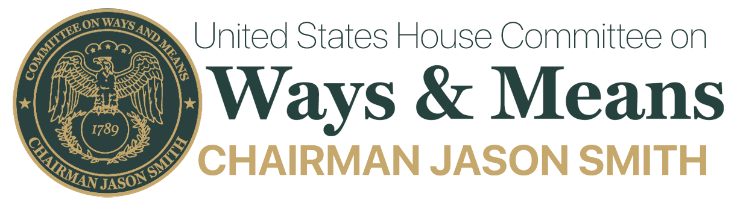

FOR IMMEDIATE RELEASE CONTACT: 202-225-3625
July 2, 2025
No. SS-02

POSTPONED: Chairman Smith, Social Security Subcommittee Chairman Estes, and Work & Welfare Subcommittee Chairman LaHood Announce Joint Subcommittee Hearing on Untapped Talent in America: Removing Barriers to Work and Supporting Opportunity for Individuals with Disabilities

House Committee on Ways and Means Chairman Jason Smith (MO-08), Social Security Subcommittee Chairman Ron Estes (KS-04), and Work & Welfare Subcommittee Chairman Darin LaHood (IL-16) have postponed the joint Subcommittees on Social Security and Work & Welfare hearing to discuss barriers to work and how policymakers can support opportunities for individuals with disabilities to establish, renew, or strengthen their connection to the workforce scheduled for Wednesday, July 9, 2025, at 2:00 PM in 1100 Longworth House Office Building.

Members of the public may view the hearing via live webcast available at https://waysandmeans.house.gov. The webcast will not be available until the hearing starts.

In view of the limited time available to hear the witnesses, oral testimony at this hearing will be from invited witnesses only. However, any individual or organization not scheduled for an oral appearance may submit a written statement for consideration by the Committee and for inclusion in the printed record of the hearing.

DETAILS FOR SUBMISSION OF WRITTEN COMMENTS:

Please Note: Any person(s) and/or organization(s) wishing to submit written comments for the hearing record can do so here: WMSubmission@mail.house.gov.

Please ATTACH your submission as a Microsoft Word document in compliance with the formatting requirements listed below, by the close of business on Wednesday, July 23, 2025. For questions, or if you encounter technical problems, please call (202) 225-3625.

FORMATTING REQUIREMENTS:

The Committee relies on electronic submissions for printing the official hearing record. As always, submissions will be included in the record according to the discretion of the Committee. The Committee will not alter the content of your submission but reserves the right to format it according to guidelines. Any submission provided to the Committee by a witness, any materials submitted for the printed record, and any written comments in response to a request for written comments must conform to the guidelines listed below. Any submission not in compliance with these guidelines will not be printed but will be maintained in the Committee files for review and use by the Committee.

All submissions and supplementary materials must be submitted in a single document via email, provided in Word format and must not exceed a total of 10 pages. Please indicate the title of the hearing as the subject line in your submission. Witnesses and submitters are advised that the Committee relies on electronic submissions for printing the official hearing record. All submissions must include a list of all clients, persons and/or organizations on whose behalf the witness appears. The name, company, address, telephone, and fax numbers of each witness must be included in the body of the email. Please exclude any personal identifiable information in the attached submission.

Failure to follow the formatting requirements may result in the exclusion of a submission. All submissions for the record are final.

ACCOMMODATIONS:

The Committee seeks to make its facilities accessible to persons with disabilities. If you require accommodations, please call 202-225-3625 or request via email to WMSubmission@mail.house.gov in advance of the event (four business days’ notice is requested). Questions regarding accommodation needs in general (including availability of Committee materials in alternative formats) may be directed to the Committee as noted above.

Note: All Committee advisories and news releases are available on the Committee website at http://www.waysandmeans.house.gov/.

###

